Peninsula Laboratories International, Inc.
305 Old County Road, San Carlos, CA 94070
Tel: (650) 801-6090
Fax: (650) 595-4071

Cat. No. S-1483

Hepcidin-25 (rat)

(for rat serum and plasma samples)

SPECIFICATIONS: Extraction-free kit for rat serum/plasma

STANDARD: 1 μg H-Asp-Thr-Asn-Phe-Pro-Ile-Cys-Leu-Phe-Cys-Cys-Lys-Cys-Cys-Lys-Asn-Ser-Ser-Cys-Gly-Leu-Cys-Cys-Ile-Thr-OH

PROTOCOL: V (Ab1hr.Std2hr.BtON)
RANGE: 0-100 ng/ml
AVERAGE IC₅₀: 6 ng/ml
SHELF-LIFE: One year from production date

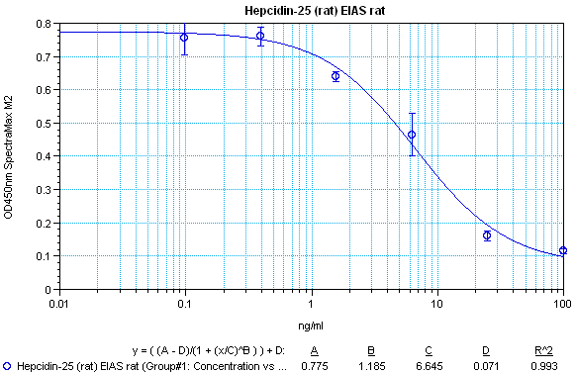

CROSS REACTION:
PEPTIDE %
Hepcidin-25 (rat) 100
Hepcidin-25 (human) 10
Hepcidin-25 (mouse) 0

